Bash script pn

DATE 30-06-2025

1. Write a bash script to perform basic arithmetic operations: addition, subtraction, multiplication, and division of two numbers.
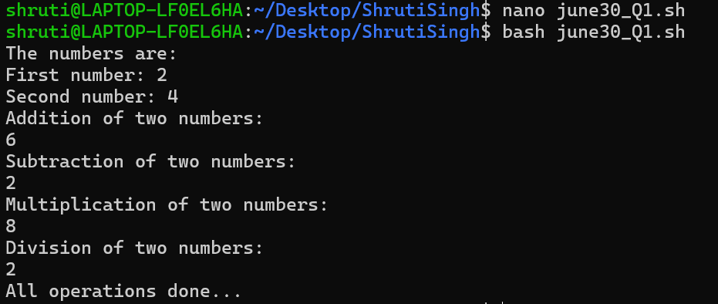
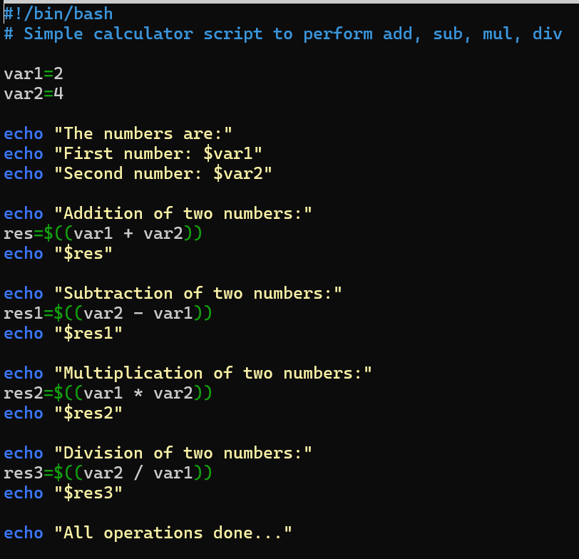

2. Write a bash script to copy all log files from /var/log to a new folder named newfolder inside your directory.
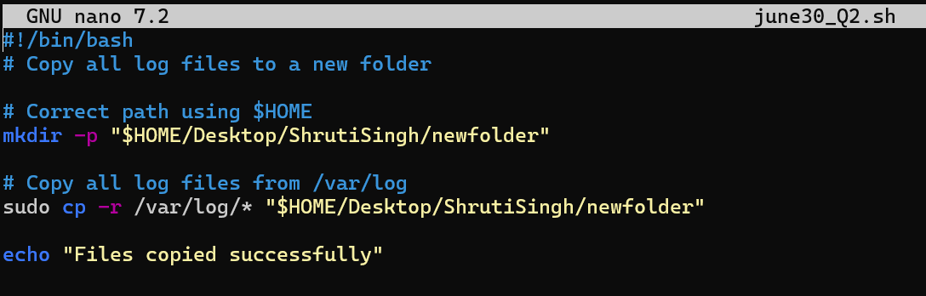

3. Write a bash script to convert all .txt files in a directory to .php files in the same directory.
#!/bin/bash
# Convert all .txt files to .php files in the directory

cd “$HOME/Desktop/ShrutiSingh/newfolder”

for file in *.txt; do
newname="${file%.txt}.php"
mv "$file" "$newname"
done

echo “.txt files have been converted to .php”
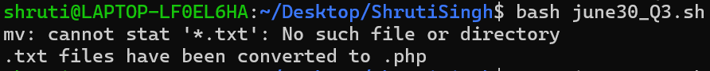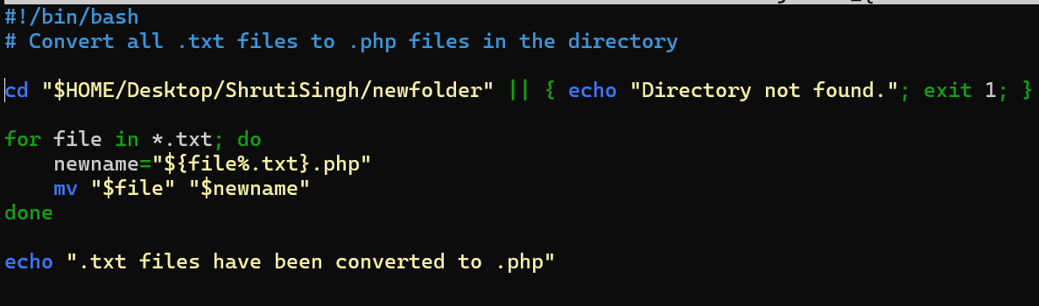

4. Write a bash script to check whether the nginx service is running. If not, start the nginx service.
#!/bin/bash
# Check and start nginx if it's not running

status=$(systemctl is-active nginx)

if [ "$status" != "active" ]; then
echo "Nginx is not running. Starting nginx..."
sudo systemctl start nginx
else
echo "Nginx is already running."
fi

# Display active status
sudo systemctl status nginx | grep 'Active'

first we have to install the nginx
sudo apt update
sudo apt install nginx -y
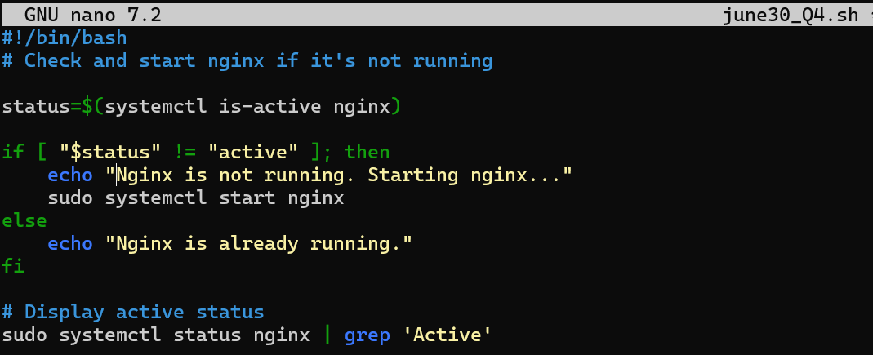

5. Write a bash script to take backup of a folder and compress it into a .tar.gz file.
#!/bin/bash
# Script to back up a folder and compress it into a .tar.gz file

echo "Enter the full path of the folder you want to back up:"
read source_folder

# Check if the folder exists
if [ ! -d "$source_folder" ]; then
echo "The folder '$source_folder' does not exist."
exit 1
fi

# Ask for destination backup folder path
echo "Enter the full path where you want to store the backup (it will be created if not exists):"
read backup_folder

# Create backup folder if it does not exist
mkdir -p "$backup_folder"

# Get folder name (e.g., myfolder2 from /home/user/myfolder2)
folder_name=$(basename "$source_folder")
timestamp=$(date +%Y%m%d_%H%M%S)

# Set backup archive name with timestamp
backup_file="$backup_folder/${folder_name}_backup_$timestamp.tar.gz"

# Create tar.gz archive
echo "Creating compressed backup at: $backup_file"
tar -czf "$backup_file" -C "$(dirname "$source_folder")" "$folder_name"

echo "Backup completed successfully!"
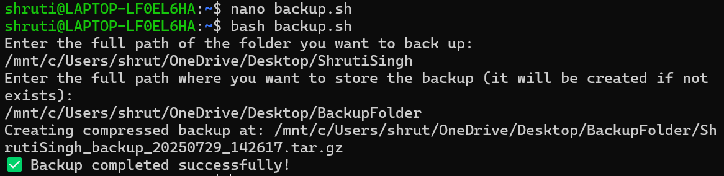

DATE 01-07-2025

1. Write a bash script that uses the find command to locate the full path of a directory named conf.d starting from the root (/). Then, replace all / characters in the path with - and print the transformed path. If the conf.d directory is not found, print an appropriate message.

#!/bin/bash

# Use find to locate the conf.d directory (suppress errors)
out=$(find / -type d -name "conf.d" 2>/dev/null)

# Check if conf.d was found
if [ -z "$out" ]; then
echo "conf.d not found"
exit 1
fi

# Replace all "/" with "-"
fout=${out//\//-}

# Print the modified path
echo "$fout"
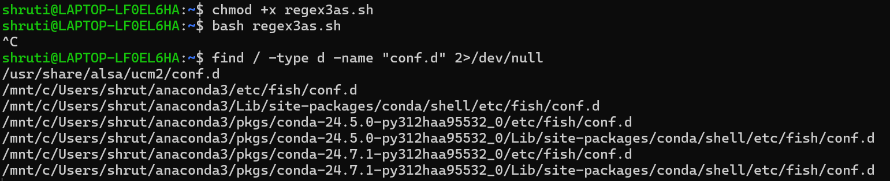
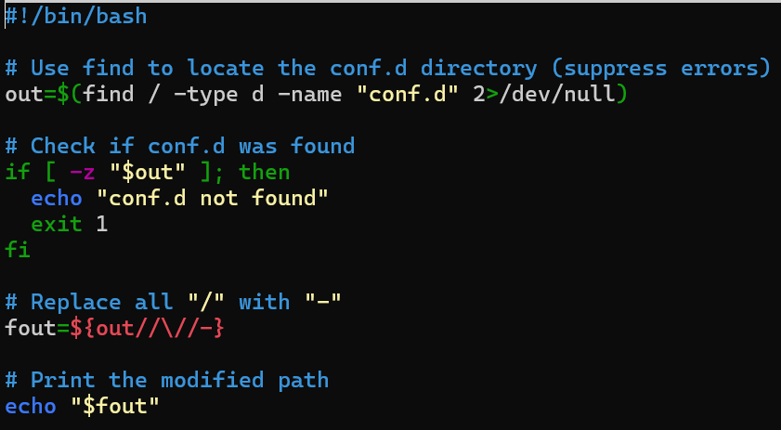

Write a bash script to print the name of the person who last logged into the system. From the /home folder, find out if any files are owned by this user. Also, find the total login time of this user.

#!/bin/bash
# Script to find last logged-in user and check file ownership

user=$(last -w | grep -m 1 'logged in' | awk '{print $1}')
echo "Last logged-in user: $user"

home="/home/$user"

if [ -d "$home" ]; then
echo "Files owned by $user in $home:"
find "$home" -user "$user" 2>/dev/null
else
echo "Home directory not found for $user"
fi

echo "Total login time for $user:"
last "$user" | awk '{print $1, $2, $3, $4, $5, $6, $7}' | head -5
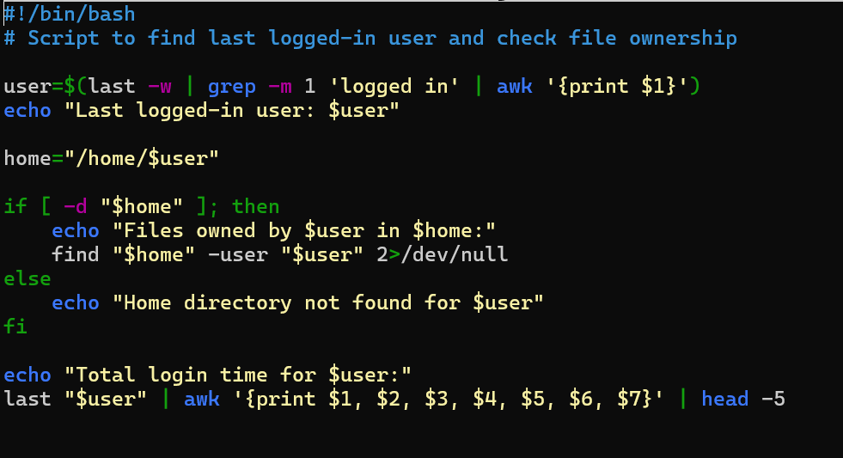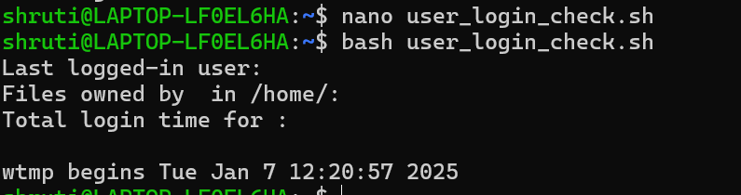

3. Write a bash script to find the latest file in any given folder (passed as a command-line argument). Make a copy of the file and find the most occurring word in it.
#! /bin/bash
# bash script to find the latest file in any given folder. the folder should be presented as a command line # argument make a copy of the file and find the most occurring word in the file

#!/bin/bash
# Check if folder is passed as command-line argument if [ ! "$1" ]; then
echo "Please give folder in CLI" exit 1
fi
folder="$1"

# Get the latest file in the folder using ls -t latest=$(ls -t "$folder" 2>/dev/null | head -n 1)

# Check if any file was found if [ ! "$latest" ]; then echo "No such files found" exit 1 fi
fpath="$folder/$latest" cname="copy_$latest" # Copy the file cp "$fpath" "$cname" echo "Copied $latest to $cname"

# Find the most occurring word (split by space, sort, count, get top)
word=$(tr '[:space:]' '\n' < "$cname" | grep -v '^$' | sort | uniq -c | sort -nr | head -n 1)

echo "Most occurring word:" echo "$word"

DATE 03-07-2025

1. Write a Bash script to create an AWS IAM user by taking the username as input. After creation, print the User ID, Username, and the Creation Timestamp. Store the output temporarily in a JSON file and remove it at the end.

#! /bin/bash
# write a bash script to create an aws user in the script find out user id and name of the user also print # the creation timestamp.

echo "Enter the username:" read usn
aws iam create-user --user-name $usn > create-user-output.json

user_id=$(jq -r '.User.UserId' create-user-output.json)
crdate=$(jq -r '.User.CreateDate' create-user-output.json)

echo "IAM user created successfully!"
echo "Username :$usn"
echo "Used ID :$user_id"
echo "Created At :$crdate"

rm create-user-output.json
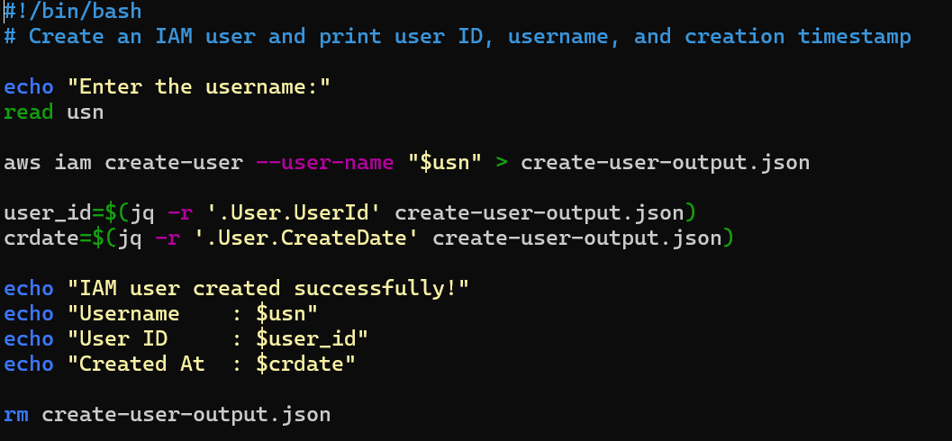
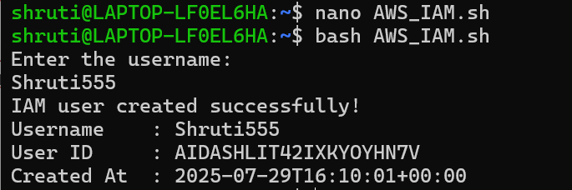

2. Write a Bash script to create an IAM user and attach the following policies:
- AmazonEC2FullAccess
- AdministratorAccess
- IAMFullAccess

#! /bin/bash
echo "Enter the username:" read usnr
aws iam create-user --user-name $usnr
aws iam attach-user-policy --user-name $usnr --policy-arn arn:aws:iam::aws:policy/AmazonEC2FullAccess aws iam attach-user-policy --user-name $usnr --policy-arn arn:aws:iam::aws:policy/AdministratorAccess
aws iam attach-user-policy --user-name $usnr --policy-arn arn:aws:iam::aws:policy/IAMFullAccess

echo "User created successfully and policies attached"
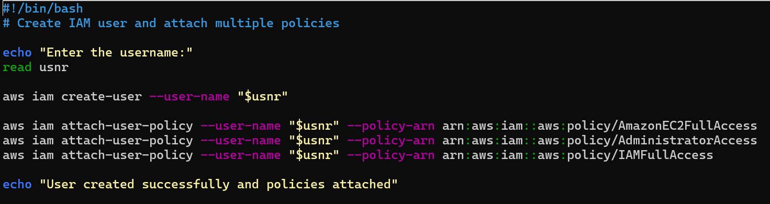
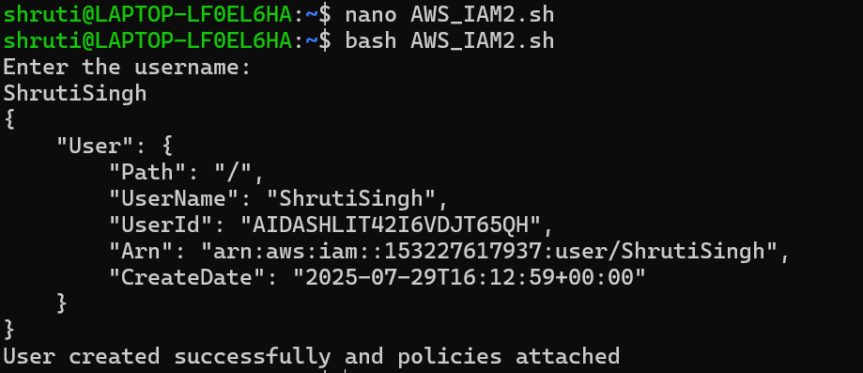

3. Write a Bash script to create an IAM user named Test and attach the AdministratorAccess policy to it.
#! /bin/bash
IAM="test" # you can provide your own username which you want to create echo "creating user"
aws iam create-user --user-name "$IAM" echo "Attaching Administrator Policy"
aws iam attach-user-policy --user-name "$IAM" --policy-arn arn:aws:iam::aws:policy/AdministratorAccess echo "done"

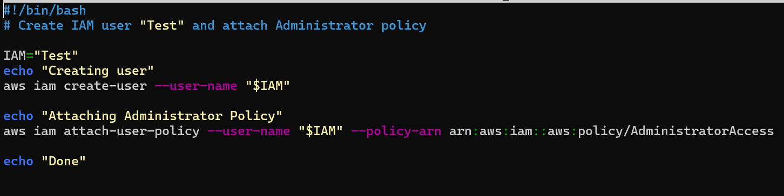
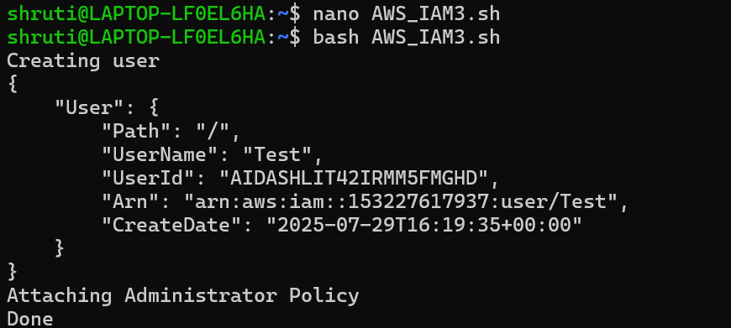

4. Extend the above script to:
- Create users Test1 and Test2
- Create a group called testing
- Add both users to the group
- Create a custom IAM role called Tester-role
- Create and attach a custom policy Tester-policy that grants read-only access to S3 to the role
- Attach the policy to the role

#! /bin/bash
# extend the above bash script to create another user named Test2.Add Test1 and Test2 to a user group # named testing( which should also be created through the script).Attach Tester-Role to all users in the # user group testing .

echo "Creating IAM Role:Tester-role"

aws iam create-role \
--role-name Tester-role \ # you can write your own role name
--assume-role-policy-document '{
"Version": "2012-10-17",
"Statement": [
{
"Effect": "Allow",
"Principal": { "Service": "ec2.amazonaws.com" },
"Action": "sts:AssumeRole"
}
]
}'

echo "Creating IAM ROle: Tester-policy" POLICY_ARN=$(aws iam create-policy \
--policy-name Tester-Policy \
--policy-document '{
"Version": "2012-10-17",
"Statement": [
{
"Effect": "Allow",
"Action": [
"s3:Get*",
"s3:List*"
],
"Resource": "*"
}
]
}' --query 'Policy.Arn' --output text)

echo "Attaching Tester-Policy to Tester-role"
aws iam attach-role-policy --role-name Tester-role --policy-arn "$POLICY_ARN"

echo "Creating group:"
aws iam create-group --group-name testing

echo "Creating users"
aws iam create-user --user-name Test1 aws iam create-user --user-name Test2

echo "Adding user to group testing"
aws iam add-user-to-group --user-name Test1 --group-name testing aws iam add-user-to-group --user-name Test2 --group-name testing
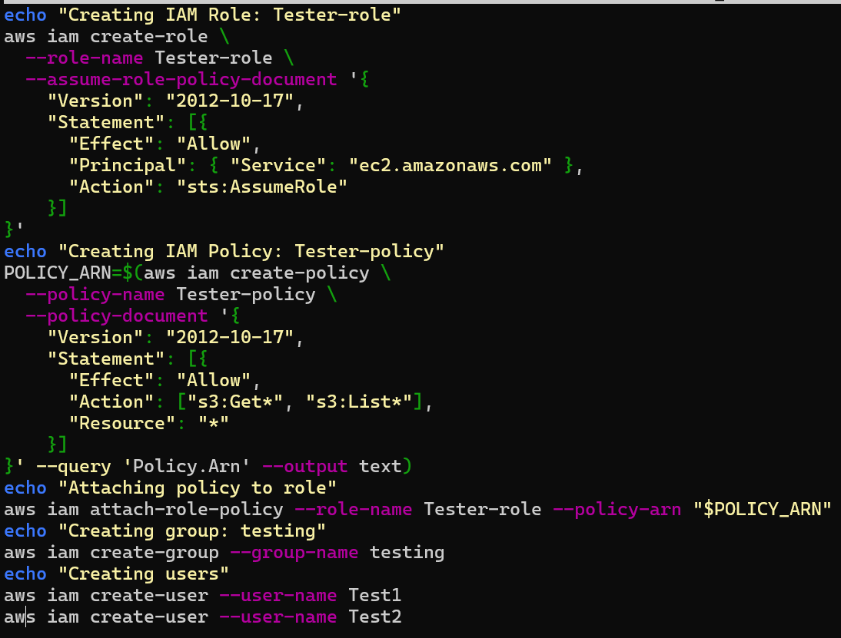
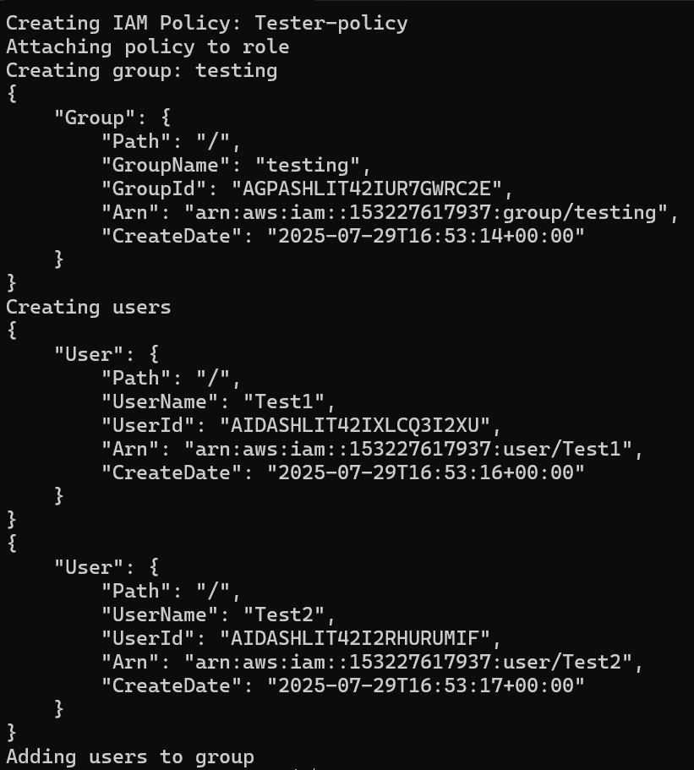

5. Write a Bash script to:
- Create an IAM role named Tester-role
- Create an IAM policy Tester-policy that provides read-only access to S3
- Attach this policy to the role

#!/bin/bash
# Create role and attach read-only S3 policy

echo "Creating IAM Role: Tester-role"
aws iam create-role --role-name Tester-role \
--assume-role-policy-document '{
"Version": "2012-10-17",
"Statement": [{
"Effect": "Allow",
"Principal": { "Service": "ec2.amazonaws.com" },
"Action": "sts:AssumeRole"
}]
}'

echo "Creating IAM Policy: Tester-policy"
aws iam create-policy \
--policy-name Tester-policy \
--policy-document '{
"Version": "2012-10-17",
"Statement": [{
"Effect": "Allow",
"Action": ["s3:Get*", "s3:List*"],
"Resource": "*"
}]
}'

echo "Attaching policy to role"
aws iam attach-role-policy \
--policy-arn arn:aws:iam::aws:policy/Tester-policy \
--role-name Tester-role
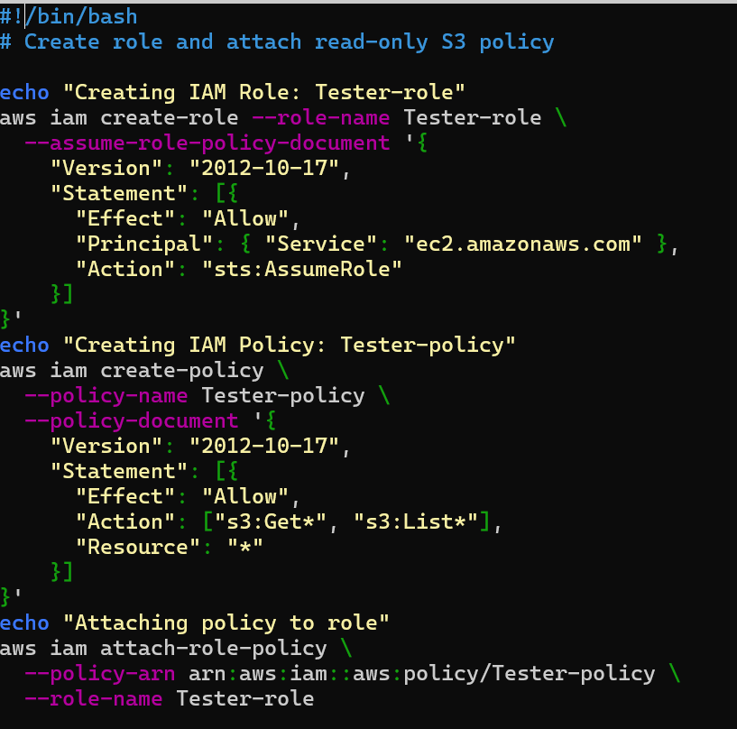

DATE 04-07-2025

1. Write a Bash script to find all available AMIs from the AMI store, and print only those AMIs which are made by Canonical.
#!/bin/bash
# Script to list Canonical AMIs

echo "Getting Canonical AMI details..."

aws ec2 describe-images \
--owners 099720109477 \
--query "Images[*].[ImageId,CreationDate]" \
--output table
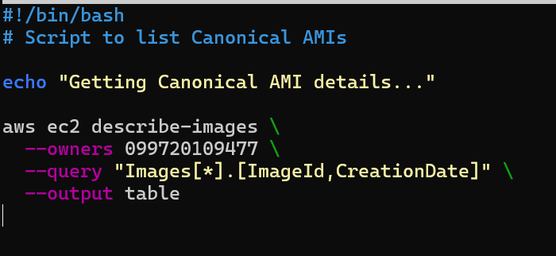
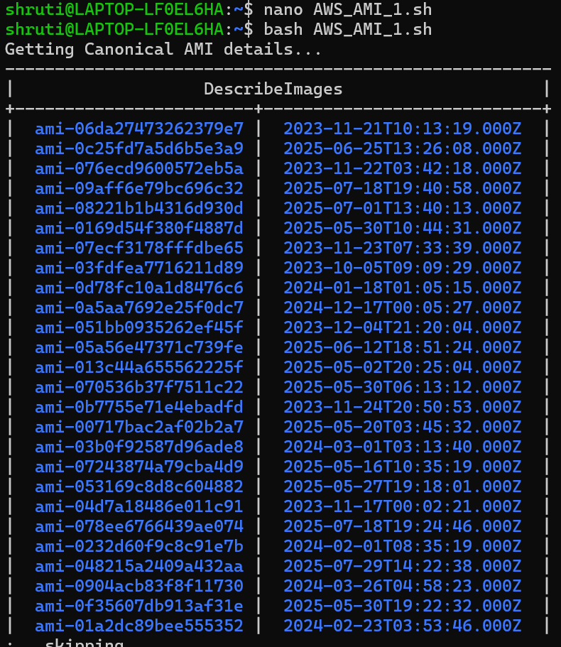
2.
Write a bash script to create a t2.micro instance and add an EBS volume to it. In the same script, terminate the earlier instance and create a new t2 instance. micro instance .Attach the EBS volume to the new instance and display the instance id of the new instance.

#!/bin/bash

REGION="${REGION:-$(aws configure get region)}"
KEY_NAME="your-key-name"
KEY_FILE="$KEY_NAME.pem"
SECURITY_GROUP_NAME="your-security-group"
INSTANCE_TYPE="t2.micro"
AMI_ID="your-ami-id"
VOLUME_SIZE=8
AVAILABILITY_ZONE="${REGION}a"

# Create Key Pair
aws ec2 create-key-pair --region "$REGION" --key-name "$KEY_NAME" --query 'KeyMaterial' --output text > "$KEY_FILE"
chmod 400 "$KEY_FILE"

# Create Security Group
SECURITY_GROUP_ID=$(aws ec2 create-security-group --region "$REGION" --group-name "$SECURITY_GROUP_NAME" --description "SG for instance" --query 'GroupId' --output text)
aws ec2 authorize-security-group-ingress --region "$REGION" --group-id "$SECURITY_GROUP_ID" --protocol tcp --port 22 --cidr 0.0.0.0/0

# Launch EC2 Instance
INSTANCE_ID_1=$(aws ec2 run-instances \
--region "$REGION" \
--image-id "$AMI_ID" \
--count 1 \
--instance-type "$INSTANCE_TYPE" \
--key-name "$KEY_NAME" \
--security-group-ids "$SECURITY_GROUP_ID" \
--query "Instances[0].InstanceId" \
--output text)

echo "Launched Instance: $INSTANCE_ID_1"

# Create EBS Volume
VOLUME_ID=$(aws ec2 create-volume \
--region "$REGION" \
--availability-zone "$AVAILABILITY_ZONE" \
--size "$VOLUME_SIZE" \
--volume-type gp2 \
--query 'VolumeId' \
--output text)

aws ec2 wait volume-available --volume-ids "$VOLUME_ID"
aws ec2 attach-volume --volume-id "$VOLUME_ID" --instance-id "$INSTANCE_ID_1" --device /dev/sdf

# Terminate First Instance
aws ec2 terminate-instances --instance-ids "$INSTANCE_ID_1"
aws ec2 wait instance-terminated --instance-ids "$INSTANCE_ID_1"

# Launch New Instance
INSTANCE_ID_2=$(aws ec2 run-instances \
--region "$REGION" \
--image-id "$AMI_ID" \
--count 1 \
--instance-type "$INSTANCE_TYPE" \
--key-name "$KEY_NAME" \
--security-group-ids "$SECURITY_GROUP_ID" \
--query "Instances[0].InstanceId" \
--output text)

aws ec2 wait instance-running --instance-ids "$INSTANCE_ID_2"
aws ec2 attach-volume --volume-id "$VOLUME_ID" --instance-id "$INSTANCE_ID_2" --device /dev/sdf

echo "New instance ID: $INSTANCE_ID_2"

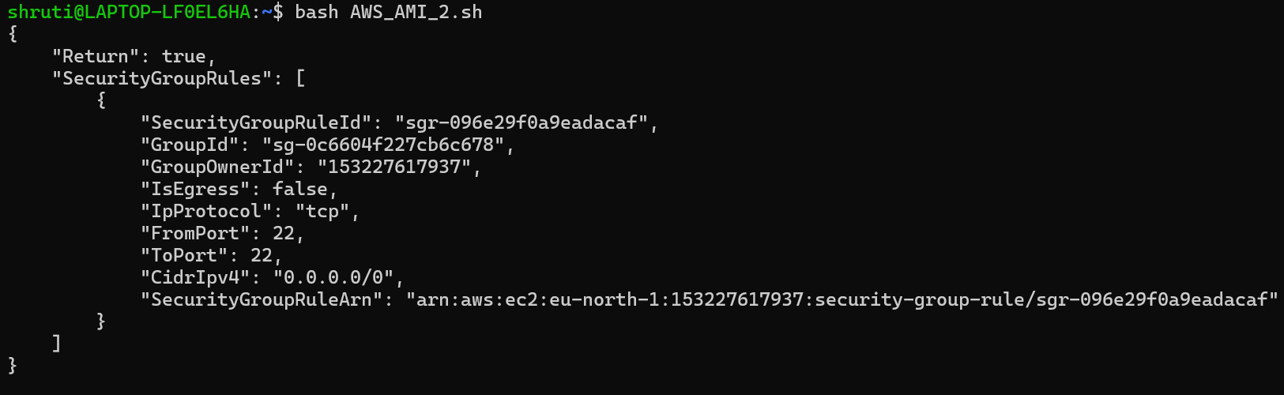

Q3. write a bash script to create a t2.micro instance and ubuntu 22.04 as the AMI

#!/bin/bash

# Configuration
REGION="${REGION:-$(aws configure get region)}"
KEY_NAME="#######" # provide your own key name
KEY_FILE="$KEY_NAME.pem"
SECURITY_GROUP_NAME="#####" # provide your own security group name
INSTANCE_TYPE="t2.micro" # give the type of instance
SCRIPT_FILE="setup.sh"

echo "Creating key pair: $KEY_NAME\n"
aws ec2 create-key-pair --region "$REGION" --key-name "$KEY_NAME" --query 'KeyMaterial' -output text > "$KEY_FILE" echo $KEY_FILE chmod 400 "$KEY_FILE" echo "Key saved to $KEY_FILE"

echo " Creating security group: $SECURITY_GROUP_NAME"
SECURITY_GROUP_ID=$(aws ec2 create-security-group --region "$REGION" --group-name
"$SECURITY_GROUP_NAME" --description "Security group for Ubuntu instance" --query 'GroupId'
--output text)
echo $SECURITY_GROUP_ID
echo "Security group created: $SECURITY_GROUP_ID"

#Alternative ways to extract Security Group ID:
# SECURITY_GROUP_ID=$(aws ec2 create-security-group ... --output text | awk '{print $1}')
# SECURITY_GROUP_ID=$(aws ec2 create-security-group ... --output text | cut -f1)
# SECURITY_GROUP_ID=$(aws ec2 create-security-group ... --output text | sed -n '1p')
# SECURITY_GROUP_ID=$(aws ec2 create-security-group ... --output text | grep -o 'sg-[a-zA-Z09]*')

echo "Authorizing SSH (port 22) access"
aws ec2 authorize-security-group-ingress --region "$REGION" --group-id "$SECURITY_GROUP_ID" --protocol tcp --port 22 --cidr 0.0.0.0/0

echo "Fetching latest Ubuntu 22.04 LTS AMI ID..."
AMI_ID=$(aws ec2 describe-images \
--region "$REGION" \
--owners 099720109477 \
--filters \
"Name=name,Values=ubuntu/images/hvm-ssd/ubuntu-jammy-22.04-amd64-server-*" \
"Name=architecture,Values=x86_64" \
"Name=virtualization-type,Values=hvm" \
"Name=root-device-type,Values=ebs" \
--query 'Images[*].[ImageId,CreationDate]' \
--output text | \ sort -k2 -r | \ head -n 1 | \ awk '{print $1}')

echo "Latest AMI ID found: $AMI_ID"
# Alternative ways to extract Instance ID:
# Alternative 1: Using cut
# AMI_ID=$(aws ec2 describe-images --region "$REGION" --owners 099720109477 \
# --filters "Name=name,Values=ubuntu/images/hvm-ssd/ubuntu-jammy-22.04-amd64-server-*" \
# "Name=architecture,Values=x86_64" "Name=virtualization-type,Values=hvm" \
# "Name=root-device-type,Values=ebs" \
# --query 'Images[*].[ImageId,CreationDate]' --output text | sort -k2 -r | head -n 1 | cut -f1)

# Alternative 2: Using sed + awk
# AMI_ID=$(aws ec2 describe-images --region "$REGION" --owners 099720109477 \
# --filters "Name=name,Values=ubuntu/images/hvm-ssd/ubuntu-jammy-22.04-amd64-server-*" \
# "Name=architecture,Values=x86_64" "Name=virtualization-type,Values=hvm" \
# "Name=root-device-type,Values=ebs" \
# --query 'Images[*].[ImageId,CreationDate]' --output text | sort -k2 -r | sed -n '1p' | awk '{print $1}')

# Alternative 3: Using grep -o
# AMI_ID=$(aws ec2 describe-images --region "$REGION" --owners 099720109477 \
# AMI_ID=$(aws ec2 describe-images --region "$REGION" --owners 099720109477 \
# --filters "Name=name,Values=ubuntu/images/hvm-ssd/ubuntu-jammy-22.04-amd64-server-*" \
# "Name=architecture,Values=x86_64" "Name=virtualization-type,Values=hvm" \
# "Name=root-device-type,Values=ebs" \
# --query 'Images[*].[ImageId,CreationDate]' --output text | sort -k2 -r | head -n 1 | grep -o 'ami-[a-zAZ0-9]\+')
# Step 5: Launch the EC2 instance

echo "Launching EC2 instance..." INSTANCE_ID=$(aws ec2 run-instances \
--region "$REGION" \
--image-id "$AMI_ID" \
--count 1 \
--instance-type "$INSTANCE_TYPE" \
--key-name "$KEY_NAME" \
--security-group-ids "$SECURITY_GROUP_ID" \
--query "Instances[0].InstanceId" \
--output text)

echo "Instance launched! ID: $INSTANCE_ID" # Alternative ways to extract Instance ID:
# INSTANCE_ID=$(aws ec2 run-instances ... --output text | awk '{print $1}')
# INSTANCE_ID=$(aws ec2 run-instances ... --output text | cut -f1)
# INSTANCE_ID=$(aws ec2 run-instances ... --output text | sed -n '1p')
# INSTANCE_ID=$(aws ec2 run-instances ... --output text | grep -o 'i-[a-zA-Z0-9]*')

PUBLIC_IP=$(aws ec2 describe-instances \
--region "$REGION" \
--instance-ids "$INSTANCE_ID" \
--query "Reservations[0].Instances[0].PublicIpAddress" \
--output text)

echo "Public IP: $PUBLIC_IP"
echo "Connect using: ssh -i $KEY_FILE ubuntu@$PUBLIC_IP"

echo "Sending $SCRIPT_FILE to EC2 instance at $PUBLIC_IP..." scp -i "$KEY_FILE" "$SCRIPT_FILE" ubuntu@"$PUBLIC_IP":~
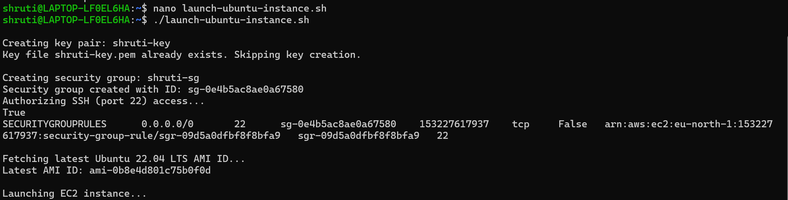

4.write a bash script to create an instance and display its public ip and public dns

#!/bin/bash

# Configuration
AMI_ID="ami-03b371d239dfe4af4"
INSTANCE_TYPE="t3.micro"
KEY_NAME="ubuntu-key" # Replace with your actual key name
SECURITY_GROUP="ubuntu-sg" # Replace with your security group name
REGION="eu-north-1"

echo "Launching EC2 instance..."

# Launch the instance
INSTANCE_ID=$(aws ec2 run-instances \
--image-id $AMI_ID \
--count 1 \
--instance-type $INSTANCE_TYPE \
--key-name $KEY_NAME \
--security-groups $SECURITY_GROUP \
--region $REGION \
--query 'Instances[0].InstanceId' \
--output text)

echo "Instance launched with ID: $INSTANCE_ID"

# Wait for the instance to be in 'running' state
echo "Waiting for instance to enter 'running' state..."
aws ec2 wait instance-running \
--instance-ids $INSTANCE_ID \
--region $REGION

# Fetch public IP and DNS
PUBLIC_IP=$(aws ec2 describe-instances \
--instance-ids $INSTANCE_ID \
--region $REGION \
--query 'Reservations[0].Instances[0].PublicIpAddress' \
--output text)

PUBLIC_DNS=$(aws ec2 describe-instances \
--instance-ids $INSTANCE_ID \
--region $REGION \
--query 'Reservations[0].Instances[0].PublicDnsName' \
--output text)

# Display the info
echo "Instance is running!"
echo "Public IP Address: $PUBLIC_IP"
echo "Public DNS Name: $PUBLIC_DNS"

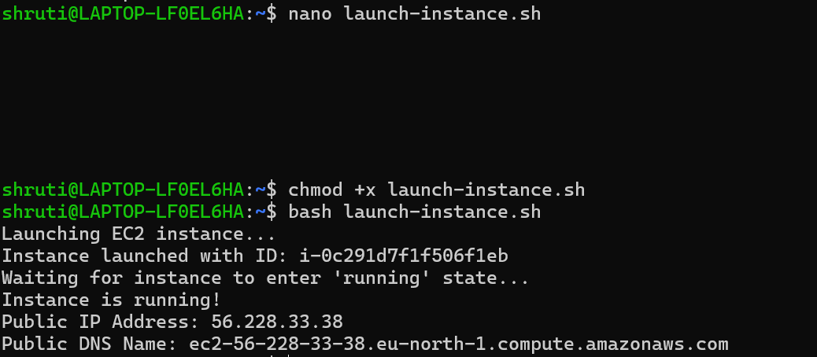
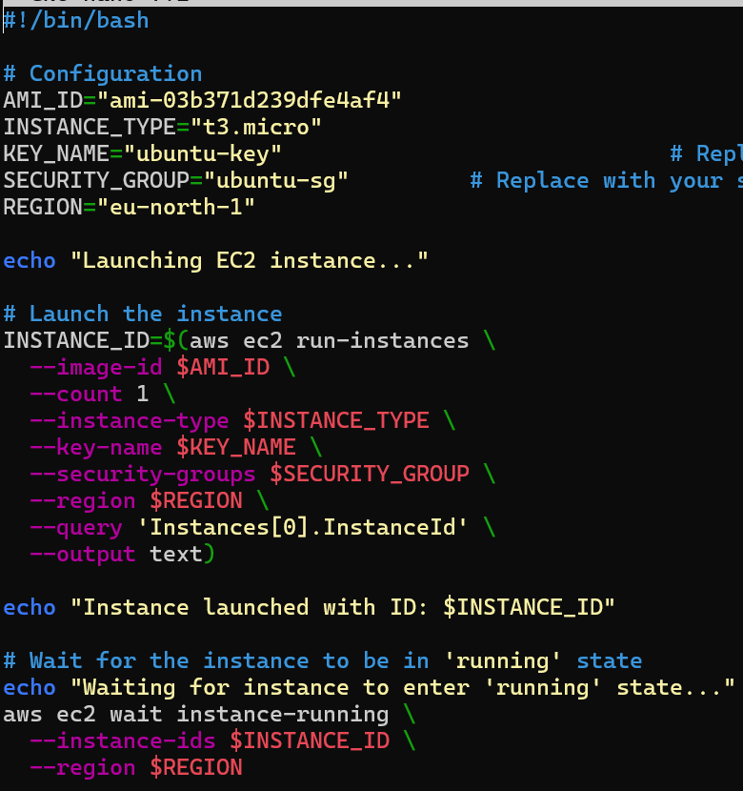
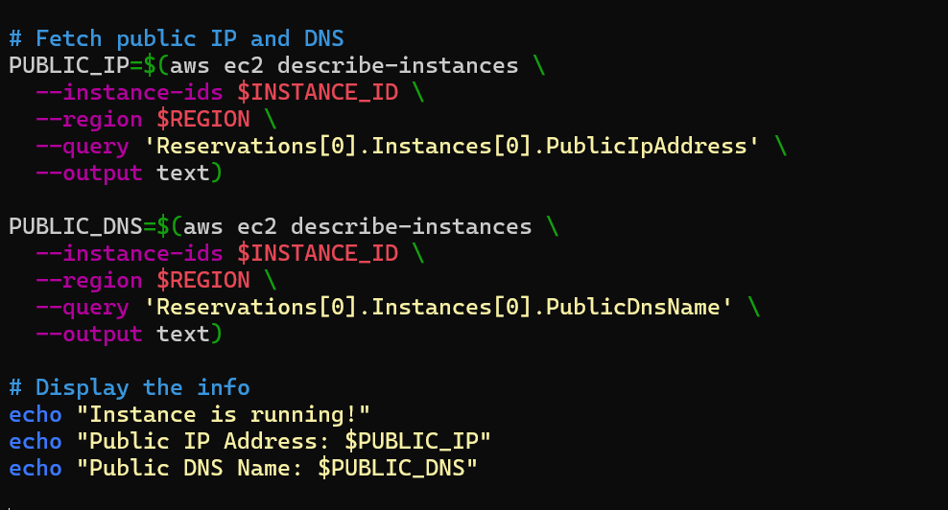

5.write a bash script to create an instance and check whether it has a elastic IP assigned to it or not

#!/bin/bash

# Configuration
AMI_ID="ami-03b371d239dfe4af4"
INSTANCE_TYPE="t3.micro"
KEY_NAME="ubuntu-key"
SECURITY_GROUP="ubuntu-sg"
REGION="eu-north-1"

echo "Launching EC2 instance..."

# Launch instance
INSTANCE_ID=$(aws ec2 run-instances \
--image-id $AMI_ID --count 1 \
--instance-type $INSTANCE_TYPE \
--key-name $KEY_NAME \
--security-groups $SECURITY_GROUP \
--region $REGION \
--query 'Instances[0].InstanceId' --output text)

echo "Instance ID: $INSTANCE_ID"

# Wait for it to run
aws ec2 wait instance-running --instance-ids $INSTANCE_ID --region $REGION

# Get IP and DNS
PUBLIC_IP=$(aws ec2 describe-instances --instance-ids $INSTANCE_ID --region $REGION \
--query 'Reservations[0].Instances[0].PublicIpAddress' --output text)

PUBLIC_DNS=$(aws ec2 describe-instances --instance-ids $INSTANCE_ID --region $REGION \
--query 'Reservations[0].Instances[0].PublicDnsName' --output text)

echo "Public IP: $PUBLIC_IP"
echo "Public DNS: $PUBLIC_DNS"

# Check Elastic IP
IS_EIP=$(aws ec2 describe-addresses --region $REGION \
--query "Addresses[?InstanceId=='$INSTANCE_ID']" --output text)

if [ -z "$IS_EIP" ]; then
echo "Elastic IP: Not associated"
else
echo "Elastic IP: Associated"
fi
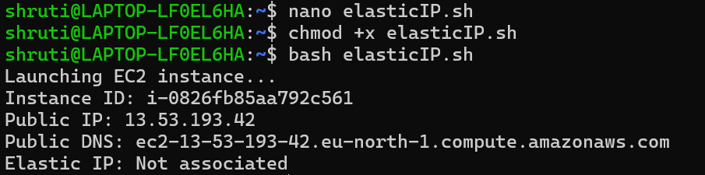
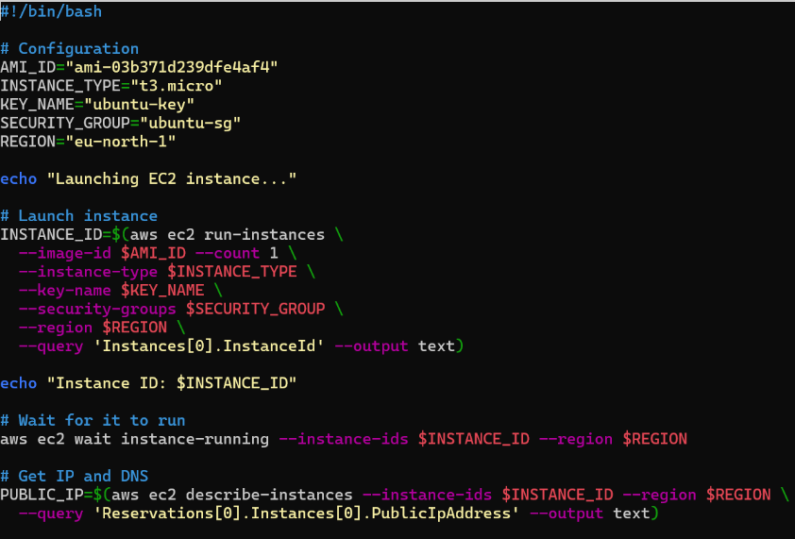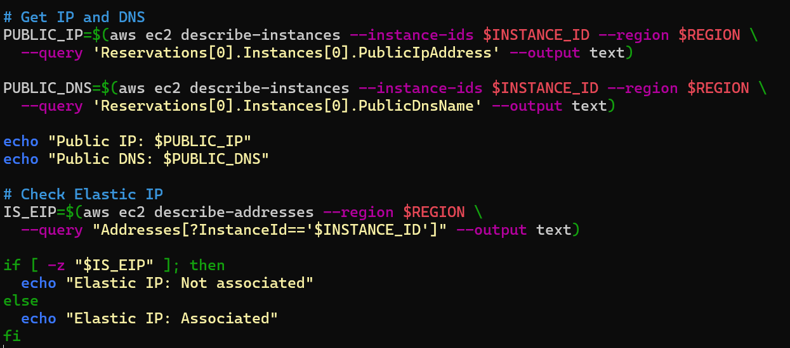

6. Write a bash script to create a key pair ,security-group and create the instance using the key pair and security-group
#!/bin/bash
# Configuration
REGION="${REGION:-$(aws configure get region)}"
KEY_NAME="ubuntu-key-6"
KEY_FILE="$KEY_NAME.pem"
SECURITY_GROUP_NAME="ubuntu-sg_35_07_2025"
INSTANCE_TYPE="t3.micro"
AMI_ID="ami-0f5ee92e2d63afc18"

# Create Key Pair
echo -e "\nCreating key pair: $KEY_NAME"
aws ec2 create-key-pair \
--region "$REGION" \
--key-name "$KEY_NAME" \
--query 'KeyMaterial' \
--output text > "$KEY_FILE"

chmod 400 "$KEY_FILE"
echo "Key saved to $KEY_FILE"

# Create Security Group
echo -e "\nCreating security group: $SECURITY_GROUP_NAME"
SECURITY_GROUP_ID=$(aws ec2 create-security-group \
--region "$REGION" \
--group-name "$SECURITY_GROUP_NAME" \
--description "Security group for Ubuntu instance" \
--query 'GroupId' \
--output text)
echo "Security group created: $SECURITY_GROUP_ID"

# Launch EC2 Instance
echo -e "\nLaunching EC2 instance..."
INSTANCE_ID=$(aws ec2 run-instances \
--region "$REGION" \
--image-id "$AMI_ID" \
--count 1 \
--instance-type "$INSTANCE_TYPE" \
--key-name "$KEY_NAME" \
--security-group-ids "$SECURITY_GROUP_ID" \
--query "Instances[0].InstanceId" \
--output text)

echo "Instance launched! ID: $INSTANCE_ID"
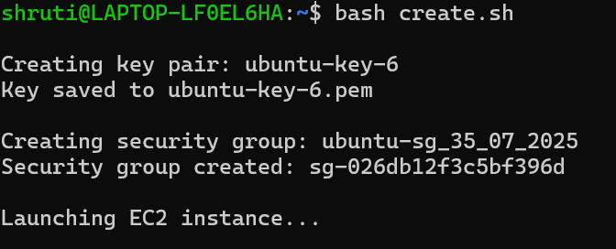

7. write a script to create an ec2 instance and ssh into it and install nginx. how can you access the nginx page.

#!/bin/bash

# Configuration
REGION="${REGION:-$(aws configure get region)}"
KEY_NAME="ubuntu-key" # provide your own key name
KEY_FILE="$KEY_NAME.pem"
SECURITY_GROUP_NAME="ubuntu-sg" # provide your own security group name
INSTANCE_TYPE="t3.micro" # give the type of instance
SCRIPT_FILE="setup.sh"
AMI_ID="xxxxxxxxxxxxxxxxx" #provide the ami id

echo "Creating key pair: $KEY_NAME\n"
aws ec2 create-key-pair --region "$REGION" --key-name "$KEY_NAME" --query 'KeyMaterial' -output text > "$KEY_FILE" echo $KEY_FILE chmod 400 "$KEY_FILE"
echo "Key saved to $KEY_FILE"

echo " Creating security group: $SECURITY_GROUP_NAME"
SECURITY_GROUP_ID=$(aws ec2 create-security-group --region "$REGION" --group-name
"$SECURITY_GROUP_NAME" --description "Security group for Ubuntu instance" --query 'GroupId'
--output text)
echo $SECURITY_GROUP_ID
echo "Security group created: $SECURITY_GROUP_ID"
# Step 3: Authorize SSH access echo "Authorizing SSH (port 22) access" aws ec2 authorize-security-group-ingress --region "$REGION" --group-id "$SECURITY_GROUP_ID" --protocol tcp --port 22 --cidr 0.0.0.0/0

echo "Launching EC2 instance..." INSTANCE_ID=$(aws ec2 run-instances \
--region "$REGION" \
--image-id "$AMI_ID" \
--count 1 \
--instance-type "$INSTANCE_TYPE" \
--key-name "$KEY_NAME" \
--security-group-ids "$SECURITY_GROUP_ID" \
--query "Instances[0].InstanceId" \
--output text)

echo "Instance launched! ID: $INSTANCE_ID"

echo "Waiting for instance to be running..."
aws ec2 wait instance-running --instance-ids "$INSTANCE_ID" --region "$REGION"

# Step-4 Get Public IP
PUBLIC_IP=$(aws ec2 describe-instances \
--instance-ids "$INSTANCE_ID" \
--region "$REGION" \
--query 'Reservations[0].Instances[0].PublicIpAddress' \
--output text)

echo "Instance is running at: $PUBLIC_IP"

# Step-5 SSH into instance and install NGINX echo "Installing NGINX on EC2 instance..."
ssh -o "StrictHostKeyChecking=no" -i "${KEY_NAME}.pem" ec2-user@"$PUBLIC_IP" << 'EOF' sudo yum update -y
sudo amazon-linux-extras install nginx1 -y sudo systemctl start nginx sudo systemctl enable nginx
EOF

# Step-6 Access NGINX
echo " NGINX is installed and running."
echo " Open this in your browser: http://$PUBLIC_IP"

8.write a bash script to create an ec2 instance and ssh into it from the script.

#!/bin/bash

# Configuration
REGION="${REGION:-$(aws configure get region)}"
KEY_NAME="ubuntu-key" # provide your own key name
KEY_FILE="$KEY_NAME.pem"
SECURITY_GROUP_NAME="ubuntu-sg" # provide your own security group name INSTANCE_TYPE="t3.micro" # give the type of instance
SCRIPT_FILE="setup.sh"
AMI_ID="xxxxxxxxxxxxxxxxxxxxx" #provide the ami id

echo "Creating key pair: $KEY_NAME\n"
aws ec2 create-key-pair --region "$REGION" --key-name "$KEY_NAME" --query 'KeyMaterial' -output text > "$KEY_FILE" echo $KEY_FILE chmod 400 "$KEY_FILE"
echo "Key saved to $KEY_FILE"

echo " Creating security group: $SECURITY_GROUP_NAME"
SECURITY_GROUP_ID=$(aws ec2 create-security-group --region "$REGION" --group-name
"$SECURITY_GROUP_NAME" --description "Security group for Ubuntu instance" --query 'GroupId'
--output text)
echo $SECURITY_GROUP_ID
echo "Security group created: $SECURITY_GROUP_ID"

echo "Authorizing SSH (port 22) access"
aws ec2 authorize-security-group-ingress --region "$REGION" --group-id "$SECURITY_GROUP_ID" --protocol tcp --port 22 --cidr 0.0.0.0/0

echo "Launching EC2 instance..." INSTANCE_ID=$(aws ec2 run-instances \
--region "$REGION" \
--image-id "$AMI_ID" \
--count 1 \
--instance-type "$INSTANCE_TYPE" \
--key-name "$KEY_NAME" \
--security-group-ids "$SECURITY_GROUP_ID" \
--query "Instances[0].InstanceId" \
--output text)

echo "Instance launched! ID: $INSTANCE_ID"
PUBLIC_IP=$(aws ec2 describe-instances \
--region "$REGION" \
--instance-ids "$INSTANCE_ID" \
--query "Reservations[0].Instances[0].PublicIpAddress" \ --output text)

echo "Public IP: $PUBLIC_IP"
echo "Connect using: ssh -i $KEY_FILE ubuntu@$PUBLIC_IP"

9. write a bash script to create an instance using ubuntu free tier AMI the script should create a key pair
and attach it to an instance, It must also create an security group where ssh is allowed from anywhere and http is allowed from my ip once instance is created the script, must print the instance id only and after creating find the id and also print dns of instance.

# !/bin/bash

# Configuration
REGION="${REGION:-$(aws configure get region)}"
KEY_NAME="ubuntu-key" # provide your own key name
KEY_FILE="$KEY_NAME.pem"
SECURITY_GROUP_NAME="ubuntu-sg" # provide your own security group
INSTANCE_TYPE="t3.micro" #give the type of instance
SCRIPT_FILE="setup.sh"
AMI_ID="xxxxxxxxxxxxxxxxxxxx" #provide the ami id

# Get My IP
MY_IP=$(curl -s http://checkip.amazonaws.com) echo "Your IP: $MY_IP"

echo "Creating key pair: $KEY_NAME\n"
aws ec2 create-key-pair --region "$REGION" --key-name "$KEY_NAME" --query 'KeyMaterial' -output text > "$KEY_FILE" echo $KEY_FILE chmod 400 "$KEY_FILE"
echo "Key saved to $KEY_FILE"

echo " Creating security group: $SECURITY_GROUP_NAME"
SECURITY_GROUP_ID=$(aws ec2 create-security-group --region "$REGION" --group-name
"$SECURITY_GROUP_NAME" --description "Security group for Ubuntu instance" --query 'GroupId'
--output text)
echo $SECURITY_GROUP_ID
echo "Security group created: $SECURITY_GROUP_ID"

echo "Authorizing SSH (port 22) access" aws ec2 authorize-security-group-ingress --region "$REGION" --group-id
"$SECURITY_GROUP_ID" --protocol tcp --port 22 --cidr 0.0.0.0/0
# Allow HTTP from your IP only
aws ec2 authorize-security-group-ingress --group-id "$SECURITY_GROUP_ID" --protocol tcp --port 80 --cidr "$MY_IP/32" --region "$REGION"

echo "Launching EC2 instance..." INSTANCE_ID=$(aws ec2 run-instances \
--region "$REGION" \
--image-id "$AMI_ID" \
--count 1 \
--instance-type "$INSTANCE_TYPE" \
--key-name "$KEY_NAME" \
--security-group-ids "$SECURITY_GROUP_ID" \
--query "Instances[0].InstanceId" \
--output text)

echo "Instance launched! ID: $INSTANCE_ID"

PUBLIC_DNS=$(aws ec2 describe-instances \
--instance-ids $INSTANCE_ID \
--region $REGION \
--query "Reservations[0].Instances[0].PublicDnsName" \
--output text)
echo "Public dns: $PUBLIC_DNS"

# --------------Output --------------
echo "Instance ID: $INSTANCE_ID" echo " Public DNS: $PUBLIC_DNS

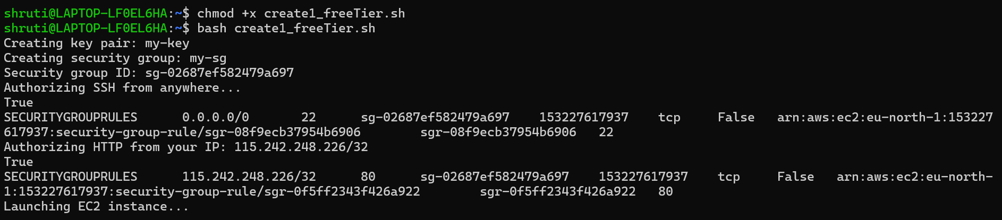

DATE 07-07-2025

1. write a bash script to create a bucket and encrypt the bucket.

#!/bin/bash
bucket_name="shruti-bucket-$(date +%s)"
aws s3 mb s3://$bucket_name
aws s3api put-bucket-encryption --bucket $bucket_name --server-side-encryption-configuration '{"Rules":[{"ApplyServerSideEncryptionB>echo "Bucket created and encrypted: $bucket_name"
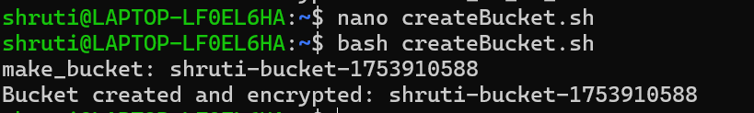

2. write a bash script to create a s3 bucket .the bucket name should be created using a random function where you have no idea of the name of the bucket. use some commands to retrieve the bucket name and cp a script file to it. Display the content of the bucket and delete it.

#!/bin/bash
# Generate a random bucket name
bucket="shruti-bucket-$RANDOM-$RANDOM"

# Create the bucket
aws s3 mb s3://$bucket
# Copy a script file to the bucket (replace with your actual file)
aws s3 cp myscript.sh s3://$bucket/
# List contents of the bucket
aws s3 ls s3://$bucket/
# Delete the bucket and its contents
aws s3 rb s3://$bucket --force
# Print bucket name
echo "Bucket used: $bucket"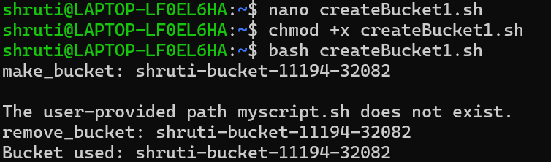
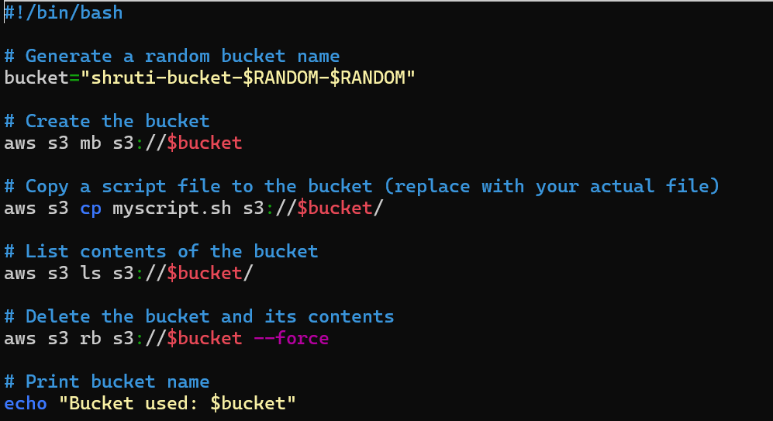

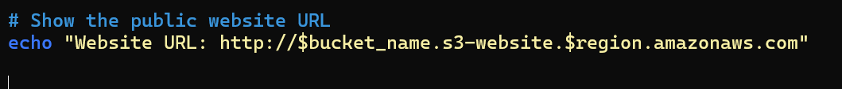
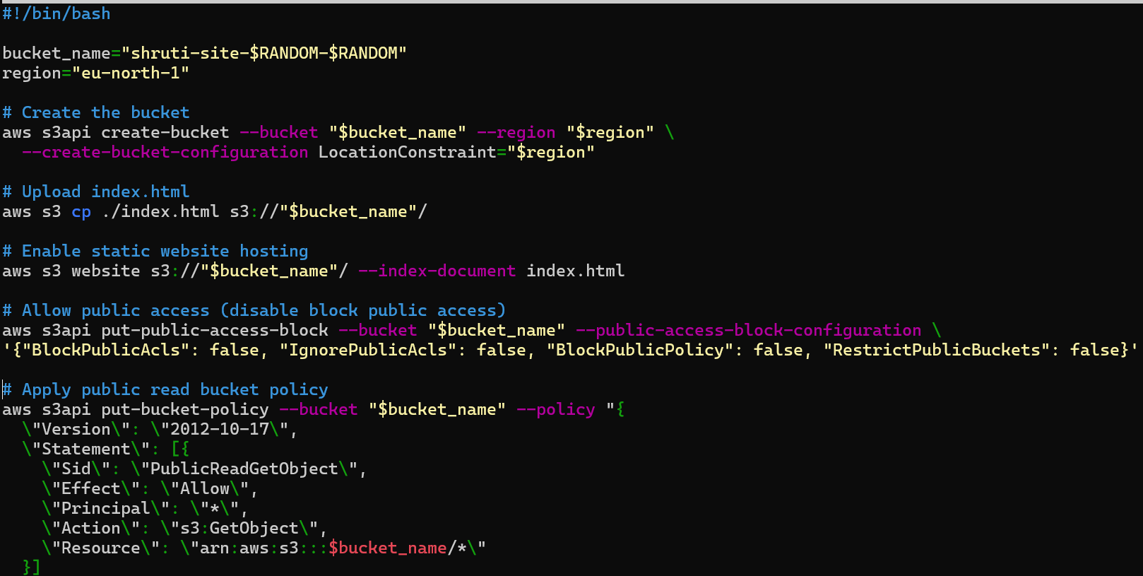
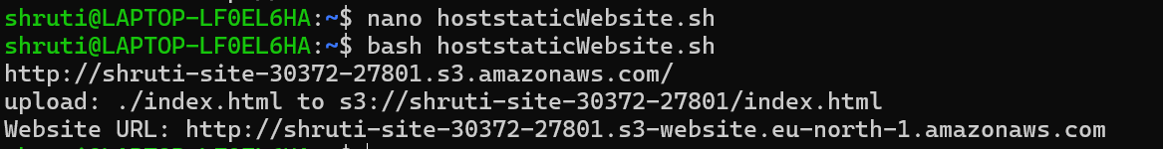
4. #write a bash script to create a bucket and host a static website in it is the website accessible through curl and through browser.

5. write a bash script to create bucket and configured as a website the script also upload index.html and error.html to the bucket it should show the url of bucket and the script should also curl that url.
#!/bin/bash

bucket="shruti-site-$RANDOM-$RANDOM"
region="eu-north-1"

aws s3api create-bucket --bucket "$bucket" --region "$region" --create-bucket-configuration LocationConstraint=$region

aws s3 website s3://$bucket/ --index-document index.html --error-document error.html

aws s3 cp index.html s3://$bucket/
aws s3 cp error.html s3://$bucket/

policy='{
"Version":"2012-10-17",
"Statement":[{
"Sid":"PublicReadGetObject",
"Effect":"Allow",
"Principal":"*",
"Action":["s3:GetObject"],
"Resource":["arn:aws:s3:::'$bucket'/*"]
}]
}'

aws s3api put-bucket-policy --bucket "$bucket" --policy "$policy"

url="http://$bucket.s3-website.$region.amazonaws.com"
echo "Website URL: $url"
curl -I $url
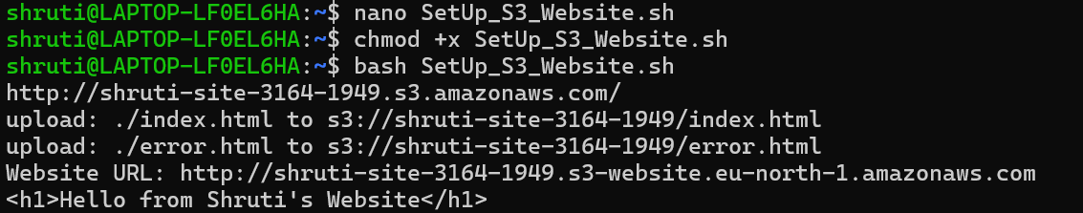

DATE 09-07-2025

1. Using AWS CLI create an EC2 instance .use some command to display the public dns address of the ec2 instance .Using the public dns ssh into the instance through the script. Write another remote script that should be copied to the ec2 .this script should contain steps to create a bucket and attach an access point to it.

DATE 10-07-2025

1. During the ssh the identity of the user in first time cannot be authorized therefore it asks for yes or no ? what can be done so that ssh does not ask for yes or no?

Solution-
1. by using StrictHostKeyChecking=no syntax- ssh -o StrictHostKeyChecking=no user@your-server-ip

DATE 11-07-2025
1.

#! /bin/bash
# create a vpc through script

vpc_id=$(aws ec2 create-vpc --cidr-block 10.0.0.0/24 --query Vpc.VpcId --output text) aws ec2 create-tags --resources "$vpc_id" --tags Key=Name,Value=vpc

#-----------Alternative-------------
#aws ec2 create-vpc \
# --cidr-block 10.0.0.0/24 \
# --tag-specifications ResourceType=vpc,Tags=[{Key=Name,Value=vpc}]
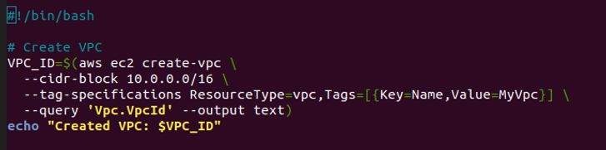

2.
#! /bin/bash
# create a vpc , subnet ,internet gateway attach ig create route table attach 0.0.0.0 to the routing table through script

echo "creating vpc...."
vpc_id=$(aws ec2 create-vpc --cidr-block 172.16.0.0/16 --query Vpc.VpcId --output text) aws ec2 create-tags --resources "$vpc_id" --tags Key=Name,Value=vpc

echo "creating & adding subnets......"
aws ec2 create-subnet --vpc-id "$vpc_id" --cidr-block 172.16.1.0/24 --query Subnet.SubnetId --output text

echo "adding internet gateway....."
ig_id=$(aws ec2 create-internet-gateway --query InternetGateway.InternetGatewayId --output text)

echo "attaching internet gateway....."
aws ec2 attach-internet-gateway --vpc-id "$vpc_id" --internet-gateway-id "$ig_id"

echo "creating route table......" rou_id=$(aws ec2 create-route-table --vpc-id "$vpc_id" --query RouteTable.RouteTableId --output text)

echo "attaching route table to ig..."
aws ec2 create-route --route-table-id "$rou_id" --destination-cidr-block 0.0.0.0/0 --gateway-id "$ig_id"

echo "done....."

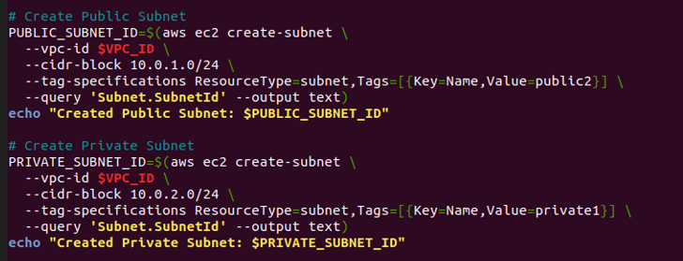
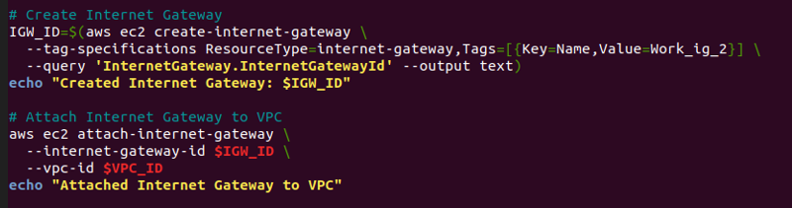

DATE 14-07-2025

1. write a bash script to create a nat gateway and attached it to the public subnet then create route table
and associate with nat gateway also with private subnet and add the destination as 0.0.0.0/0 for the
target of route select the nat gateway launch an ec2 instance in your private subnet and check if the instance is reachable or not

#!/bin/bash
# Configuration
REGION="${REGION:-$(aws configure get region)}"
KEY_NAME="ubuntu-key" # provide your own key name
KEY_FILE="$KEY_NAME.pem"
SECURITY_GROUP_NAME="ubuntu-sg" # provide your own security group
INSTANCE_TYPE="t3.micro" # give the type of instance
SCRIPT_FILE="setup.sh"
AVAILABILITY_ZONE="ap-south-1a" # provide your own availability zone
AMI_ID="xxxxxxxxxxxxxxxxxxxxx" # provide the ami id

# -------------- Creating VPC -------------- echo "Creating VPC..." VPC_ID=$(aws ec2 create-vpc \
--cidr-block 10.0.0.0/16 \
--query "Vpc.VpcId" \
--output text)
echo "VPC ID: $VPC_ID"

aws ec2 modify-vpc-attribute --vpc-id $VPC_ID --enable-dns-support "{\"Value\":true}" aws ec2 modify-vpc-attribute --vpc-id $VPC_ID --enable-dns-hostnames "{\"Value\":true}"

# -------------- Creating Subnets ------------------ echo "Creating Public Subnet..."
PUBLIC_SUBNET_ID=$(aws ec2 create-subnet \
--vpc-id $VPC_ID \
--cidr-block 10.0.1.0/24 \
--availability-zone $AVAILABILITY_ZONE \ --query "Subnet.SubnetId" --output text)
echo "Public Subnet ID: $PUBLIC_SUBNET_ID"

echo "Creating Private Subnet..."
PRIVATE_SUBNET_ID=$(aws ec2 create-subnet \
--vpc-id $VPC_ID \
--cidr-block 10.0.2.0/24 \
--availability-zone $AVAILABILITY_ZONE \ --query "Subnet.SubnetId" --output text) echo "Private Subnet ID: $PRIVATE_SUBNET_ID" # --------------- Creating and Attaching Internet Gateway -------------------- echo "Creating Internet Gateway..."
IGW_ID=$(aws ec2 create-internet-gateway \
--query "InternetGateway.InternetGatewayId" --output text)
aws ec2 attach-internet-gateway --vpc-id $VPC_ID --internet-gateway-id $IGW_ID echo "Internet Gateway ID: $IGW_ID"

# -------------------- Creating Route Table for Public Subnet --------------------- echo "Creating Public Route Table..."
PUBLIC_RT_ID=$(aws ec2 create-route-table --vpc-id $VPC_ID --query "RouteTable.RouteTableId"
--output text)
aws ec2 create-route --route-table-id $PUBLIC_RT_ID --destination-cidr-block 0.0.0.0/0 --gateway-id
$IGW_ID
aws ec2 associate-route-table --subnet-id $PUBLIC_SUBNET_ID --route-table-id $PUBLIC_RT_ID echo "Public Route Table ID: $PUBLIC_RT_ID"

# === Make Public Subnet Auto-Assign Public IPs ===
aws ec2 modify-subnet-attribute --subnet-id $PUBLIC_SUBNET_ID --map-public-ip-on-launch

# --------------- Allocating Elastic IP for NAT Gateway -------------------- echo "Allocating Elastic IP..."
EIP_ALLOC_ID=$(aws ec2 allocate-address --domain vpc --query "AllocationId" --output text) echo "Elastic IP Allocation ID: $EIP_ALLOC_ID"

# --------------- Create NAT Gateway in Public Subnet --------------------- echo "Creating NAT Gateway..."
NAT_GW_ID=$(aws ec2 create-nat-gateway \
--subnet-id $PUBLIC_SUBNET_ID \
--allocation-id $EIP_ALLOC_ID \
--query "NatGateway.NatGatewayId" --output text) echo "NAT Gateway ID: $NAT_GW_ID"

echo "Waiting for NAT Gateway to become available..." aws ec2 wait nat-gateway-available --nat-gateway-ids $NAT_GW_ID echo "NAT Gateway is available."

# -------------- Create Route Table for Private Subnet ---------------- echo "Creating Private Route Table..."
PRIVATE_RT_ID=$(aws ec2 create-route-table --vpc-id $VPC_ID --query "RouteTable.RouteTableId"
--output text)
aws ec2 create-route --route-table-id $PRIVATE_RT_ID --destination-cidr-block 0.0.0.0/0 --natgateway-id $NAT_GW_ID
aws ec2 associate-route-table --subnet-id $PRIVATE_SUBNET_ID --route-table-id $PRIVATE_RT_ID echo "Private Route Table ID: $PRIVATE_RT_ID"

# -------------- Launch EC2 instance in Private Subnet ---------------- echo "Launching EC2 Instance in Private Subnet..."
INSTANCE_ID=$(aws ec2 run-instances \
--image-id $AMI_ID \
--instance-type $INSTANCE_TYPE \
--key-name $KEY_NAME \
--subnet-id $PRIVATE_SUBNET_ID \
--security-group-ids $SECURITY_GROUP_ID \
--associate-public-ip-address false \
--query "Instances[0].InstanceId" --output text)
echo "EC2 Instance ID: $INSTANCE_ID"

echo "Waiting for EC2 instance to be running..." aws ec2 wait instance-running --instance-ids $INSTANCE_ID echo "EC2 instance is running in the private subnet."

# ---------- Summary ------------- echo "----- All Process Completed -----"
echo "VPC ID: $VPC_ID" echo "Public Subnet ID: $PUBLIC_SUBNET_ID" echo "Private Subnet ID: $PRIVATE_SUBNET_ID" echo "EC2 Instance ID (Private Subnet): $INSTANCE_ID"

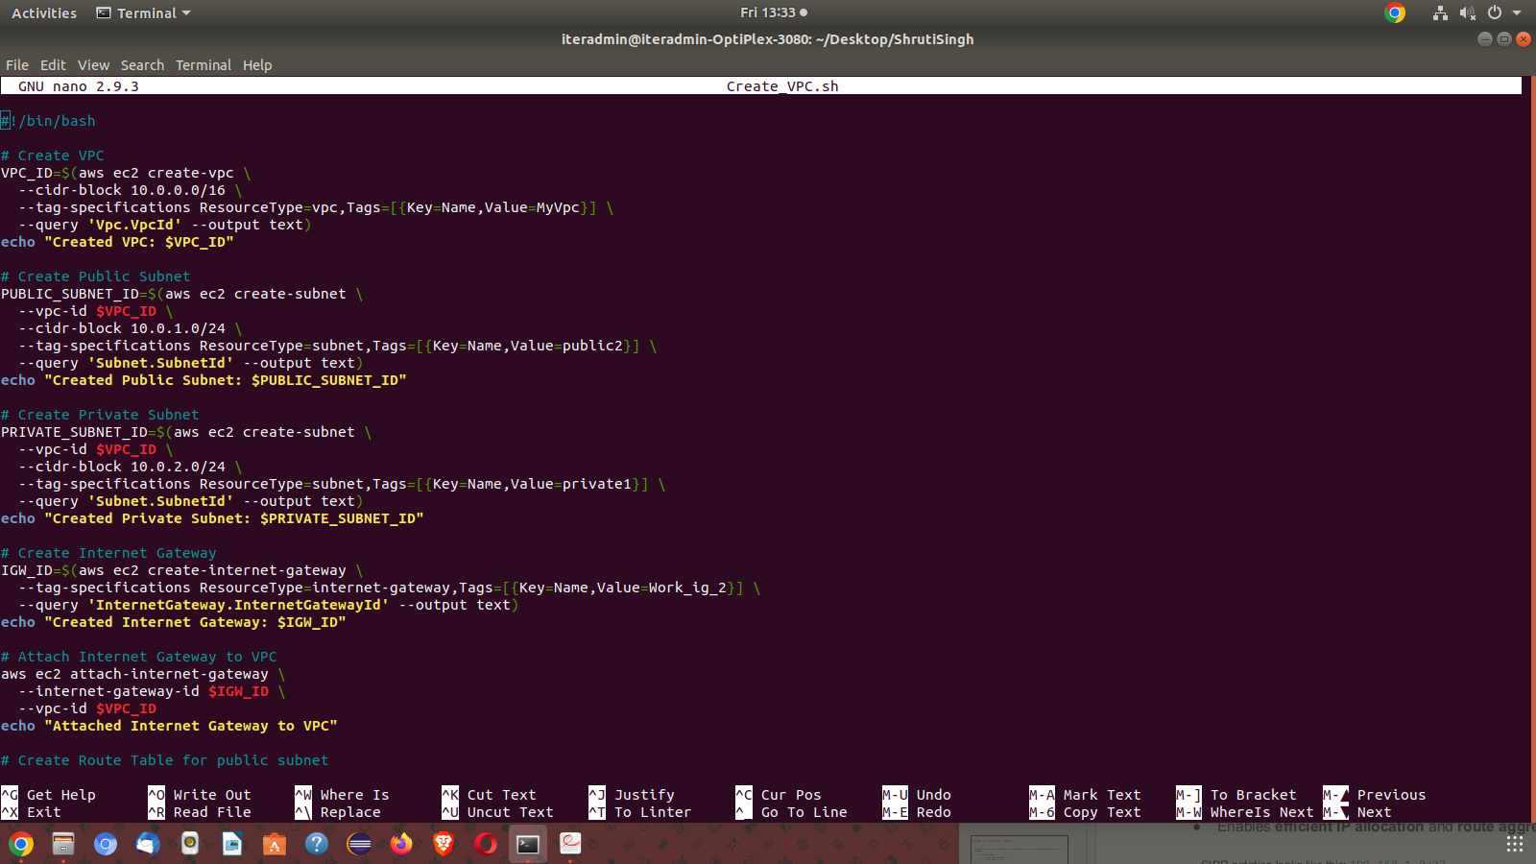

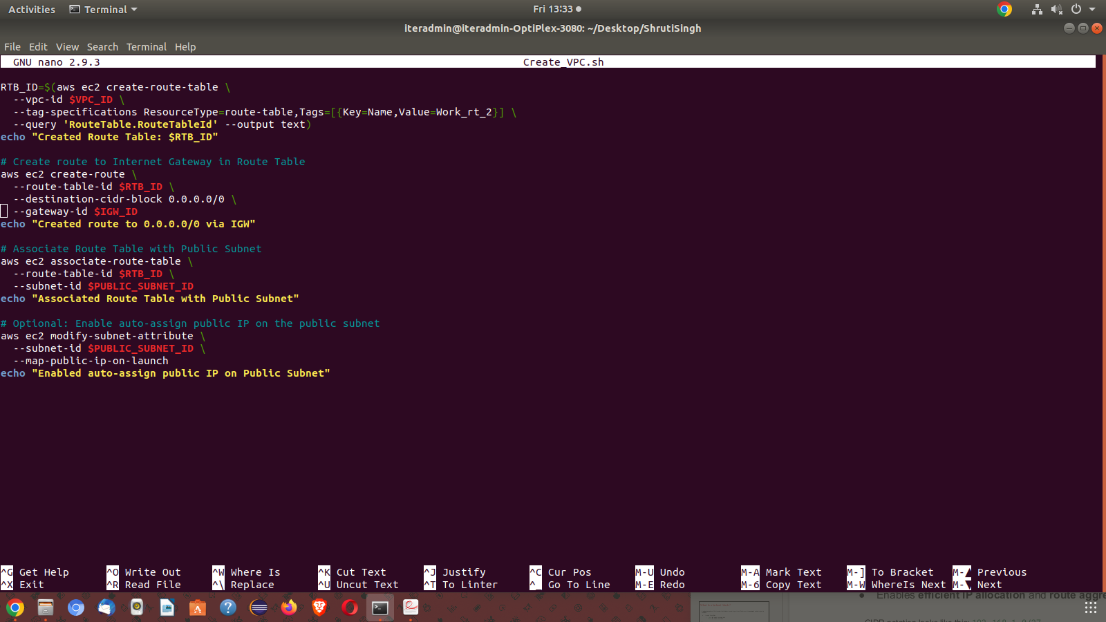

2.
Write a bash script that fetches the id of the public subnet. create an ec2 instance and attaches this instance to the public subnet .it create an alarm for cpu utilisation which triggers when the threshold is greater than 70%. create an SNS topic and attach the SNS topic to the alarm . finally it attaches the alarm to the instance created in public subnet.

#!/bin/bash

REGION=$(aws configure get region)
KEY_NAME="alarm" # provide your own key name
KEY_FILE="test_${KEY_NAME}.pem"
SECURITY_GROUP_NAME="##########" # provide your own security group
INSTANCE_TYPE="t3.micro"
AMI_ID="xxxxxxxxxxxxxxxxxxxxx" # provide the ami id
EMAIL="abccldwtch@gmail.com" #write your own email to attach SNS topic
ALARM_NAME="HighCPUAlarm"
SNS_TOPIC_NAME="HighCPUNotificationTopic"
AVAILABILITY_ZONE="ap-south-1a" # provide your own region

echo -e "Creating key pair: $KEY_NAME\n"
aws ec2 create-key-pair --region "$REGION" --key-name "$KEY_NAME" --query 'KeyMaterial' -output text > "$KEY_FILE" echo "$KEY_FILE" chmod 400 "$KEY_FILE"
echo "Key saved to $KEY_FILE"

echo "Creating security group: $SECURITY_GROUP_NAME"
SECURITY_GROUP_ID=$(aws ec2 create-security-group \
--region "$REGION" \
--group-name "$SECURITY_GROUP_NAME" \
--description "Security group for Ubuntu instance" \
--query 'GroupId' \
--output text)

echo "$SECURITY_GROUP_ID"
echo "Security group created: $SECURITY_GROUP_ID"

echo "Creating VPC..." VPC_ID=$(aws ec2 create-vpc \
--cidr-block 10.0.0.0/16 \
--query "Vpc.VpcId" \
--output text)
echo "VPC ID: $VPC_ID"

echo "Creating Public Subnet..."
PUBLIC_SUBNET_ID=$(aws ec2 create-subnet \
--vpc-id "$VPC_ID" \
--cidr-block 10.0.1.0/24 \
--availability-zone "$AVAILABILITY_ZONE" \ --query "Subnet.SubnetId" --output text) echo "Public Subnet ID: $PUBLIC_SUBNET_ID"

if [ "$PUBLIC_SUBNET_ID" == "None" ]; then echo "No public subnet found in VPC $VPC_ID. Exiting." exit 1 fi

echo "Found Public Subnet: $PUBLIC_SUBNET_ID"

echo "Launching EC2 instance..." INSTANCE_ID=$(aws ec2 run-instances \
--image-id "$AMI_ID" \
--instance-type "$INSTANCE_TYPE" \ --key-name "$KEY_NAME" \
--subnet-id "$PUBLIC_SUBNET_ID" \
--security-group-ids "$SECURITY_GROUP_ID" \
--associate-public-ip-address \
--query "Instances[0].InstanceId" --output text)

echo "Launched EC2 Instance: $INSTANCE_ID"

echo "Creating SNS Topic..."
TOPIC_ARN=$(aws sns create-topic --name "$SNS_TOPIC_NAME" --query "TopicArn" --output text)
aws sns subscribe --topic-arn "$TOPIC_ARN" --protocol email --notification-endpoint "$EMAIL" echo "Subscription confirmation email sent to: $EMAIL" echo "Waiting 30 seconds for SNS topic setup..." sleep 30

echo "Creating CloudWatch alarm for CPU utilization > 70%..." aws cloudwatch put-metric-alarm \
--alarm-name "$ALARM_NAME" \
--alarm-description "Alarm when CPU > 70%" \
--metric-name CPUUtilization \
--namespace AWS/EC2 \
--statistic Average \
--period 300 \
--threshold 70 \
--comparison-operator GreaterThanThreshold \
--dimensions "Name=InstanceId,Value=$INSTANCE_ID" \
--evaluation-periods 1 \
--alarm-actions "$TOPIC_ARN"

echo "Alarm $ALARM_NAME created and attached to instance $INSTANCE_ID" echo "All steps completed successfully!"

DATE 15-07-2025
1.
write a bash script that launches an instance in the public subnet an sends a script to the instance .the script must install terraform in the instance but not using snap. create a folder for terraform project .create main.tf with providers initialize the project.

2.
write a user data script for ubuntu instance that bootstrap the instance and install the lamp server.

DATE 16-07-2025
1.Using terraform create a vpc ,in the output block get the vpc id ,create two subnets in the vpc one named public and other named private attach a internet gateway to the VPC .create a route table open a route between public subnet and internet gateway between the destination 0.0.0.0/0.

#main.tf(main terraform file) resource "aws_vpc" "main1" { cidr_block = "10.0.0.0/16" tags = {
Name = "main-vpc"
} }
resource "aws_internet_gateway" "gw1" { vpc_id = aws_vpc.main1.id tags = {
Name = "main-gw"
} }
resource "aws_subnet" "public1" { vpc_id = aws_vpc.main1.id
cidr_block = "10.0.1.0/24"

tags = {
Name = "public-subnet"
}
}

resource "aws_subnet" "private1" { vpc_id = aws_vpc.main1.id cidr_block = "10.0.2.0/24" tags = {
Name = "private-subnet"
} }
resource "aws_route_table" "public1" { vpc_id = aws_vpc.main1.id
route {
cidr_block = "0.0.0.0/0"
gateway_id = aws_internet_gateway.gw1.id
} tags = {
Name = "public-rt"
} }
resource "aws_route_table_association" "a1" { subnet_id = aws_subnet.public1.id route_table_id = aws_route_table.public1.id
}

#provider.tf(provider file)
# The default provider configuration; resources that begin with `aws_` will use # it as the default, and it can be referenced as `aws`.
provider "aws" {
# access_key = "${var.access_key}"
# secret_key = "${var.secret_key}"
region = "ap-south-1" # provide your own region }

2. Write a bash script create the key pair, security group , subnet ,VPC and ec2 instance using terraform

Make your infrastructure(3 files in a folder) main.tf providers.tf terraform.sh

#Terraform.sh
#!/bin/bash

echo "-------- Destroying previous infrastructure --------"
terraform destroy -auto-approve
echo "-------- Initializing Terraform ----------" terraform init
echo "-------- Planning Terraform changes -------" terraform plan
echo "-------- Applying Terraform configuration --------" terraform apply -auto-approve

echo "------ Terraform process complete. --------"

main.tf

# VPC resource "aws_vpc" "main_vpc1" { cidr_block = "10.0.0.0/16"
}

# Subnet
resource "aws_subnet" "main_subnet1" { vpc_id = aws_vpc.main_vpc1.id cidr_block = "10.0.1.0/24"
}

# Key Pair
resource "tls_private_key" "example" { algorithm = "RSA" rsa_bits = 4096
}

resource "aws_key_pair" "generated_key" { key_name = "my-key"
public_key = tls_private_key.example.public_key_openssh
}

# Security Group
resource "aws_security_group" "allow_ssh" { name = "allow_ssh"
description = "Allow SSH inbound traffic" vpc_id = aws_vpc.main_vpc1.id

ingress {
from_port = 22
to_port = 22
protocol = "tcp" cidr_blocks = ["0.0.0.0/0"]
}

egress { from_port = 0 to_port = 0 protocol = "-1"
cidr_blocks = ["0.0.0.0/0"]
}
}

# EC2 Instance
resource "aws_instance" "web" {
ami = "xxxxxxxxxxxx" # provide your own ami id instance_type = "xxxxxxxxx" # provide the instance type subnet_id = aws_subnet.main_subnet1.id vpc_security_group_ids = [aws_security_group.allow_ssh.id] key_name = aws_key_pair.generated_key.key_name

tags = {
Name = "MyEC2Instance"
}
}

#provider.tf provider "aws" {
region="xxxxxxxxx" # provide your own region }

3.
write a terraform file to create the state file in a s3 bucket .create a vpc ,attach it to a public subnet and to a network interfaces. create 2 ec2 instances in the vpc. Make your infrastructure(2 files in a folder) main.tf , providers.tf

main.tf
# Remote backend - store state in S3 terraform { backend "s3" { bucket = "xxxxxxxxxxx" # Replace with your bucket name
region = "xxxxxxxxx" # provide your own region
}
}

# Create VPC resource "aws_vpc" "my_vpc" { cidr_block = "10.0.0.0/16"
}

# Create public subnet resource "aws_subnet" "my_subnet" { vpc_id = aws_vpc.my_vpc.id cidr_block = "10.0.1.0/24"
}

# Create internet gateway resource "aws_internet_gateway" "my_igw" { vpc_id = aws_vpc.my_vpc.id
} # Route table
resource "aws_route_table" "my_route_table" { vpc_id = aws_vpc.my_vpc.id

route { cidr_block = "0.0.0.0/0"
gateway_id = aws_internet_gateway.my_igw.id
}
}

# Associate route table with subnet
resource "aws_route_table_association" "my_route_assoc" { subnet_id = aws_subnet.my_subnet.id route_table_id = aws_route_table.my_route_table.id
}

# Create network interfaces resource "aws_network_interface" "test1" { subnet_id = aws_subnet.my_subnet.id
}
resource "aws_network_interface" "test2" { subnet_id = aws_subnet.my_subnet.id
}

# Create EC2 instances and attach interfaces resource "aws_instance" "ec2_1" { ami = "xxxxxxxxxxxxxxxxxxxx" # provide the ami id instance_type = "xxxxxxxxxxxx" # provide the instance type network_interface {
network_interface_id = aws_network_interface.test1.id device_index = 0
}
depends_on = [aws_network_interface.test1]
}

resource "aws_instance" "ec2_2" { ami = "xxxxxxxxxxxxxxxxxx" # provide the ami id instance_type = "xxxxxxxxxxx" # provide the instance type network_interface {
network_interface_id = aws_network_interface.test2.id device_index = 0
}
depends_on = [aws_network_interface.test2]
}

provider.tf provider "aws" {
region = "xxxxxxxxxxx" # provide your own region
}

4.
create a module named s3_module that creates a s3 bucket ,s3 bucket policy using terraform

make your infrastructure(main folder) main.tf provider.tf
s3_module/ main.tf variables.tf outputs.tf

main.tf
resource "aws_s3_bucket" "qus4" { bucket = var.bucket_name acl = var.acl
tags = {
Name = var.bucket_name
Environment = "Dev"
}
}

resource "aws_s3_bucket_policy" "qus4" { bucket = aws_s3_bucket.this.id policy = var.policy_json
}

variable.tf variable "bucket_name" {
description = "Name of the S3 bucket" type = string
}

variable "acl" {
description = "ACL for the S3 bucket (e.g., private)"
type = string default = "private"
}

variable "policy_json" {
description = "JSON bucket policy" type = string
}

outputs.tf output "bucket_name" {
description = "The name of the created S3 bucket" value = aws_s3_bucket.qus4.bucket
}

main.tf

module "my_s3" { source = "./s3_module"
bucket_name = "xxxxxxxx" # provide unique bucket name acl = "private"

policy_json = jsonencode({
Version = "2012-10-17"
Statement = [
{
Effect = "Allow"
Principal = "*"
Action = "s3:GetObject"
Resource = "arn:aws:s3:::your-bucket-name/*" #provide your bucket name
}
] })
}

Provider.tf provider "aws" {
region = "xxxxxxxxx" # provide your region
}

5.
create a terraform module for a security group that allow ssh and http traffic .attach the security group to multiple ec2 instances .create a script to all the above

make your infrastructure(main folder) main.tf provider.tf
sg_module/ main.tf variables.tf outputs.tf

sg_module/main.tf

resource "aws_security_group" "xxxxxx" { # provide security group name name = var.sg_name description = "Allow SSH and HTTP"
vpc_id = var.vpc_id

ingress { description = "SSH" from_port = 22 to_port = 22
protocol = "tcp" cidr_blocks = ["0.0.0.0/0"]
}

ingress {
description = "HTTP" from_port = 80 to_port = 80 protocol = "tcp" cidr_blocks = ["0.0.0.0/0"]
}

egress {
from_port = 0
to_port = 0
protocol = "-1"
cidr_blocks = ["0.0.0.0/0"]
}
}

sg_module/variables.tf

variable "sg_name" {
description = "Name of the security group" type = string
}

variable "vpc_id" {
description = "ID of the VPC" type = string
}

sg_module/output.tf

output "security_group_id" {
value = aws_security_group.xxxxxx.id # provide security group name
}

Provider.tf provider "aws" {
region = "xxxxxxxxxxx" # provide your region
}

main.tf

# VPC
resource "aws_vpc" "xxxxxx" { # provide your vpc name cidr_block = "10.0.0.0/16"
}

# Subnet
resource "aws_subnet" "my_subnet" { vpc_id = aws_vpc.xxxxxx.id # provide your vpc name cidr_block = "10.0.1.0/24"
}

# Internet Gateway
resource "aws_internet_gateway" "gw" {
vpc_id = aws_vpc.xxxxxx.id #provide your vpc name
}

# Route table and association resource "aws_route_table" "rt" {
vpc_id = aws_vpc.xxxxxx.id # provide your vpc name

route {
cidr_block = "0.0.0.0/0"
gateway_id = aws_internet_gateway.gw.id
}
}

resource "aws_route_table_association" "rta" { subnet_id = aws_subnet.my_subnet.id route_table_id = aws_route_table.rt.id
}

# Security group module module "xxxxxx" { source = "./sg_module" sg_name = "web-sg"
vpc_id = aws_vpc.xxxxxxx.id # provide your vpc name
}

# EC2 Instances resource "aws_instance" "web1" {
ami = "xxxxxxxxxxxxxx" #provide the ami id instance_type = "xxxxxxxx" # provide the type of instance subnet_id = aws_subnet.my_subnet.id
vpc_security_group_ids = [module.xxxxxx.security_group_id]

tags = {
Name = "WebServer1"
}
}

resource "aws_instance" "web2" {
ami = "xxxxxxxxxxxxxxxx" # provide the ami id instance_type = "xxxxxxxx" # provide the instance type subnet_id = aws_subnet.my_subnet.id
vpc_security_group_ids = [module.xxxxxx.security_group_id]

tags = {
Name = "WebServer2"
}
}

6.
Using terraform create an iam user and provide the following permissions ,EC2fullacces, Administrative Access,S3fullAccess.

Make your infrastructure/environment main.tf provider.tf

Provider.tf

provider "aws" {
region = "xxxxxxxx" #provide your own region
}

Main.tf

# Create IAM user
resource "aws_iam_user" "xxxxxxxxxxxxx" { # provide our iam user name name = "demo-user"
}

# Attach EC2 Full Access policy
resource "aws_iam_user_policy_attachment" "ec2_access" {
user = aws_iam_user.xxxxxxxxxxxxx.name # provide your iam username policy_arn = "arn:aws:iam::aws:policy/AmazonEC2FullAccess" }

# Attach S3 Full Access policy
resource "aws_iam_user_policy_attachment" "s3_access" {
user = aws_iam_user.xxxxxxxxxxxxx.name # provide your iam username policy_arn = "arn:aws:iam::aws:policy/AmazonS3FullAccess" }

# Attach Administrator Access policy
resource "aws_iam_user_policy_attachment" "admin_access" {
user = aws_iam_user.xxxxxxxxxxxxx.name # provide your iam username policy_arn = "arn:aws:iam::aws:policy/AdministratorAccess" }

7.
Create a module named vpc that creates a vpc and a subnet .store as output the VPCID and the subnet ID.

Make your infrastructure/environment main.tf provider.tf vpc/ main.tf variables.tf outputs.tf

vpc/main.tf

resource "aws_vpc" "xxxxxxxxx" { # provide your own vpc name cidr_block = var.vpc_cidr

tags = {
Name = "my-vpc"
} }
resource "aws_subnet" "my_subnet" {
vpc_id = aws_vpc.xxxxxxx.id # provide your own vpc name cidr_block = var.subnet_cidr

tags = {
Name = "my-subnet"
}
}

vpc/variables.tf variable "vpc_cidr" {
description = "CIDR block for the VPC" type = string
}

variable "subnet_cidr" {
description = "CIDR block for the subnet" type = string
}

vpc/output.tf

output "vpc_id" {
description = "The ID of the VPC"
value = aws_vpc.xxxxxxx.id # provide your own vpc name }
output "subnet_id" {
description = "The ID of the subnet" value = aws_subnet.my_subnet.id
}

provider.tf provider "aws" {
region = "xxxxxxxxxxx" # provide your own region }

main.tf
module "xxxxxxxxxx" { # provide your own vpc name source = "./vpc" vpc_cidr = "10.0.0.0/16" subnet_cidr = "10.0.1.0/24"
}

output "vpc_id" {
value = module.xxxxxxxx.vpc_id # provide your own vpc name }

output "subnet_id" {
value = module.xxxxxxxxx.subnet_id # provide your own vpc name }

DATE 19 18-07-2025

1. write a terraform file that creates a s3 bucket and uses a loop to provision all files in particular folder to the s3 bucket.

2.
write a bash script and uses terraform to create an instance in the public subnet (VPC) ,and an instance in the private subnet use file provisioner and transfer the key pair of the private instance into the public instance ssh into the public instance to private instance.

3.
write a terraform module called ec2_nginx that create an ec2 instance create a security group and attaches to that also allow aah and http use file provisioner and the remote-exec to send a script to that instance which installs nginx and run. use remote -exec to run the script from your system.

DATE 23-07-2025

1.
how to run a container from an image in the background.

docker ps
docker pull hello-world docker run -d hello-world docker ps

2.
how to run a container from and image with a user specified.

docker run -it --user 1000:1000 ubuntu bash

3.
create a docker image from app.

FROM openjdk:17
COPY /home/ubuntu/java-app/tmp
WORKDIR /tmp
RUN javac Hello.java
CMD [“java” , “Hello”]

4.
pull and run the hello world image

docker pull hello-world docker run hello-world

5.
pull and run the nginx image,check if the webpage is actively hosted.

docker pull nginx
docker run nginx

6.
pull and run MySQL container from the hub.Can you log into the that provided using -it option.

docker pull mysql
docker run --name my-mysql -e MYSQL_ROOT_PASSWORD=my-secret-pw -d mysql docker exec -it my-mysql mysql -u root -p

7.
pull the nginx image from docker hub ,rename the image to mynginx and upload it to docker hub.

docker pull nginx
docker tag nginx your-dockerhub-username/mynginx docker login
docker push your-dockerhub-username/mynginx

